**COMP103P: Object-Oriented Programming**

**ChaTale**

**By:** Wentao Wei and Fasbeer Esaknder

Team 22

**Client:** Start-up Company ChaTale

27th April 2016

Contents

1. Introduction 3

1.1 The Team: 3

1.2 The Client 4

2. Project. 5

2.1 The App. 5

2.2 Requirements Capture 5

2.3 MoSCoW 5

2.4 Use Cases. 6

3 Research: Technology and Platforms. 8

3.1 Technology and Platforms Used. 8

4 Structure 9

4.1 Design. 9

4.2 Packages. 10

5 Development and Testing. 11

5.1 Gantt Chart 11

5.2 Stages 12

6 Evaluation, Conclusion and Future Works. 13

6.1 Evaluation. 13

6.2 Conclusion 14

6.3 Future Works 14

7 References 16

8. Appendix 17

# 1. Introduction

1.1 The Team:

Our team was appointed Team 22 consisting of two members.

The Members:

Wentao Wei

First year student in computer science at UCL. Love computer science, and started programming from junior school in China. Learnt Pascal and C. No prior knowledge of other languages.

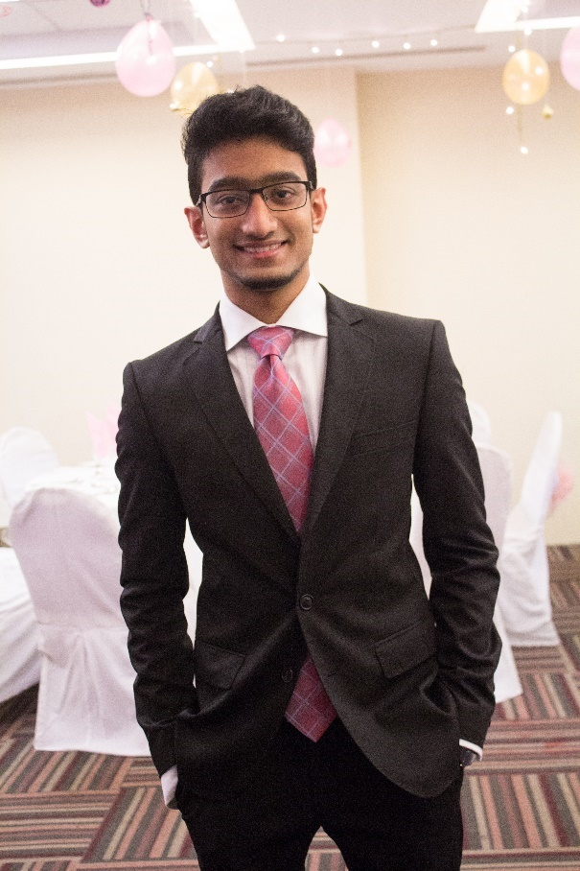

Fasbeer Eskander:

A 1st year in computer science at UCL. I've always been interested in programming and all the wonders one can do with technology if he knows how it is programmed and how to program one himself. With a keen interest on it from a child, I decided to do my BSc on computer science and learn the DNA of computer programs. I do not have prior knowledge in programming.

Team Roles:

Since it was just the two of us, we covered each other’s roles when the other was not able to do it. The main roles, however, were assigned.

Wentao Wei:

* Team Leader
* Main Contact with client.
* UI developer
* In charge of noting the minutes during the meetings
* JavaScript and CSS Developer

Fasbeer Eskander:

* UI designer.
* Prototype tester
* HTML researcher and Developer.
* Contact with UCL PGTA
* Documentation and report for project
* Bi-weekly Reports
  1. The Client

Client Company: ChaTale. IT is a fine tea subscription start-up company which delivers different kinds of teas from the world to the door of their subscribers. More information can be accessed on their website <http://www.chatale.co.uk/> .

  
 **Fig:1 Chatale Logo**

Main Contact: Chantelle Ouyang, Cofounder of the start-up ChaTale.

1. Project.

## 2.1 The App.

At first we were asked to build an app where customers can make and order their own tea blends based on the app’s recommendations. The focus of the project was to be the back end coding and UI/UX aspect of the app. However, after a few meetings, the clients changed their minds asked us to make a different app. Instead they wanted an app where their customers would be able to select ingredients from the list of ingredients available and the app would guide, step by step, on how to make the perfect tea blend with them.

The app is to be connected to the ChaTale server and database to access all the ingredients available and the information regarding how to make the tea using the ingredients selected. While the blends are mixed and laid to rest to be made to perfection, the app will play music of their choice from the phone library.

## 2.2 Requirements Capture

To capture the requirements for the app, after the first contact with our introduction via email with the client, we sent up a meeting. In the meeting we first asked about the type of app they were looking for and what they wanted to include in the app. However as stated earlier, a completely different app was asked to develop after a few meetings. In the same way at the meeting where this decision was made, we discussed with the client about how they wanted the layout of the app to be and what they wanted to be included. All the requirements were noted down.

* 1. MoSCoW

After noting down the requirements, we sat down together and prioritized them according to the MoSCoW method. This notes down the ‘Must Have’, ‘Should Have’, “Could Have’, and ‘Wont Have’ for the project, as it can be seen below. The previous MoSCoW for the other app is given in the appendices section.

Must have

* Users are able to select from one to eight ingredients.
* When “Start making tea” Button is clicked, music will be played until it countdowns to 0 (Recommended time for making tea varies)
* Different ingredients or combinations corresponding to different music.

Should have

* Categories.
* User are able to choose music that is downloaded from anywhere else to play.
* While music is being played, some useful instructions are given on the screen. (e.g. add hot water now).
* Users are able to request a password reset.
* User are able to set customized time for its tea.
* Users are able to search by keyword.
* Users are able to submit feedback via the app.

Could have

* Users are able to share this app to any kinds of social media.
* Users are able to login in with Facebook and Gmail.
* Display recently teas made.

Won’t Have

* Blank
  1. Use Cases.

We used an online tool to make the use case diagram below, we outlined the main and basic interactions the customer would make with the app.

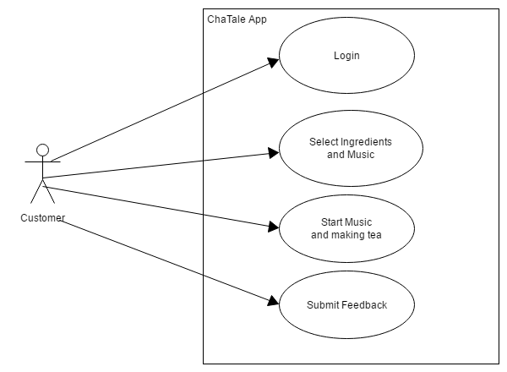

**Fig: 2 Use Case Diagram**

|  |  |  |
| --- | --- | --- |
| **Use Case** | **Primary Actor** | **Action** |
| Login | Customer | User uses their account and subscription details to login into the app. |
| Select Ingredients and Music | Customer | Use can select from 1-8 ingredients to blend into making the tea and select a music from their library. |
| Start Music and Making Tea | Customer | The user clicks a button to start playing music while the app guides the user in making the tea. |
| Submit Feedback | Customer | The User can give a feedback of the tea made and the usage of the app. |

**Table:1 Use Case Descriptions**

1. Research: Technology and Platforms.

## 3.1 Technology and Platforms Used.

To be able to make a cross-platform application, which is an app that is able to run on more than one operating software such as android, apple etc., we did some online research on the best tools to be able to do it and settled on using Cordova. It uses HTML, CSS and JavaScript and combines them to make a framework to build the app.

**HTML5:** Hyper Text Markup Language or HTML a simple markup language used to present content on the websites or application. It is the fifth version of HTML and was used to develop the app. We were both new to learning this so we referred to <http://www.w3schools.com/>.

**CSS3:** Cascading style sheets also known as CSS decide how the format and style of the web pages and applications look when viewed through different web browsers or mobile devices. It is also another markup language that uses specific notations and words to set ruled to define the HTML elements of the page or the app. To be able to build a cross-platform app, CSS played an important part on deciding how it looked on different platforms. We also used <http://www.w3schools.com/> to learn about CSS to be able to use it and develop the app.

**JavaScript:** JavaScript is a simple scripting web programming language. It’s used on almost every website to respond to user actions and also the same on the application we’ve built which gives us the ability to control what action is performed when something is done on the application. It is very different to HTML and CSS as it allows us to use conditional statements and programming syntaxes to control the behavior of the app. Again we used <http://www.w3schools.com/> to learn more about JavaScript as we both had limited knowledge on it.

**Apache Cordova:**  Apache Cordova is an open-source mobile development framework. It allows you to use standard web technologies - HTML5, CSS3, and JavaScript for cross-platform development. Applications execute within wrappers targeted to each platform, and rely on standards-compliant API bindings to access each device's capabilities such as sensors, data, network status, etc. We learnt how to use it from the guide on it’s website.

**AngularJS:** AngularJS is a structural framework for dynamic web apps. It lets you use HTML as your template language and lets you extend HTML's syntax to express your application's components clearly and succinctly. The data binding and dependency injection eliminate much of the code you would otherwise have to write.

**NetBeans:** An Integrated Development environment or IDE which can be used to easily develop desktop, mobile and web application. We used this to do all the development for the application.

**VMware:** VMware is a virtualization and cloud computing software provider for x86-compatible computers. We used this to install OS X on our windows computers to able to test the if the app worked on an iOS device, with the help of Xcode.

**Xcode:** Xcode is another IDE containing a suite of software development tools developed by Apple for developing software for OS X and iOS. We used this to emulate the app into iOS. We used this to emulate the app into an iPhone and test if it works on the VMware.

**Firebase:** Firebase is a platform for building mobile and web applications. Firebase provides database for storing and to sync the apps data. We used the database from firebase for our app.

**Ionic Creator:** Ionic Creator is a website that enables users to design apps and view the prototype design made. We used Ionic Creator for making the app prototype.

1. Structure

## 4.1 Design.

For the design and style of the app, we first made paper prototypes to show to our clients. After the decision to make a different app was made, we were shown a general idea of how the app would look like by our clients in a meeting with them then proceeded with the development of the app. For the second working prototype, we used ionic creator to design it and showed the app to our clients to confirm. The prototype can be viewed in the link <https://creator.ionic.io/share/a54a3ff0cf4a>.

## 4.2 Packages.

|  |  |  |
| --- | --- | --- |
| **Path** | **Files** | **Description** |
| Chataleapp\plugins | Plugins  (Including inappbrowser and media plugins) | Plugins used in some functions:  For example play mp3 files |
| Chataleapp\platforms | Android folder and ios folder | Files that support different platforms |
| chataleapp\www\img | 3KVYxhvDRtOUjGuchGas_logo_center.png | Chatale app icon. |
| chataleapp\www\js | App.js  Chat.js  Controller.js  Directives.js  Ng-cordova.min.js  Routes.js  Services.js  Timer.js | JavaScriptfiles which enables the app to submit feedback, login/logout with email and password, login with Facebook account, register a new account, set a timer and play audio files. |
| chataleapp\www\lib | Ionic folder  Ionicrouter folder | Libraries |
| Chataleapp\www\templates | About.html  AddNewMusic.html  Cart.html  Chatale.html  Cloud.html  Congratulations.html  contactUs.html  feedback.html  getStarted.html  ingredients.html  login.html  menu.html  myAccount.html  page.html  pleaseSelectIngredients.html  resetPassword.html  selectIngredients.html  selectMusic.html  singup.html  status.html  youAreAboutToStart.html  yourOwnMusicList.html | Pages that are used to make up our app |
| Chatale\www | Index.html | Includes all the javascript files used in building this app. |

**Table 1:** List of work packages and the files they contain (1)

1. Development and Testing.

## 5.1 Gantt Chart

We divided our work into different stages. We had a few problems in between and with time management, and the stages are given below.

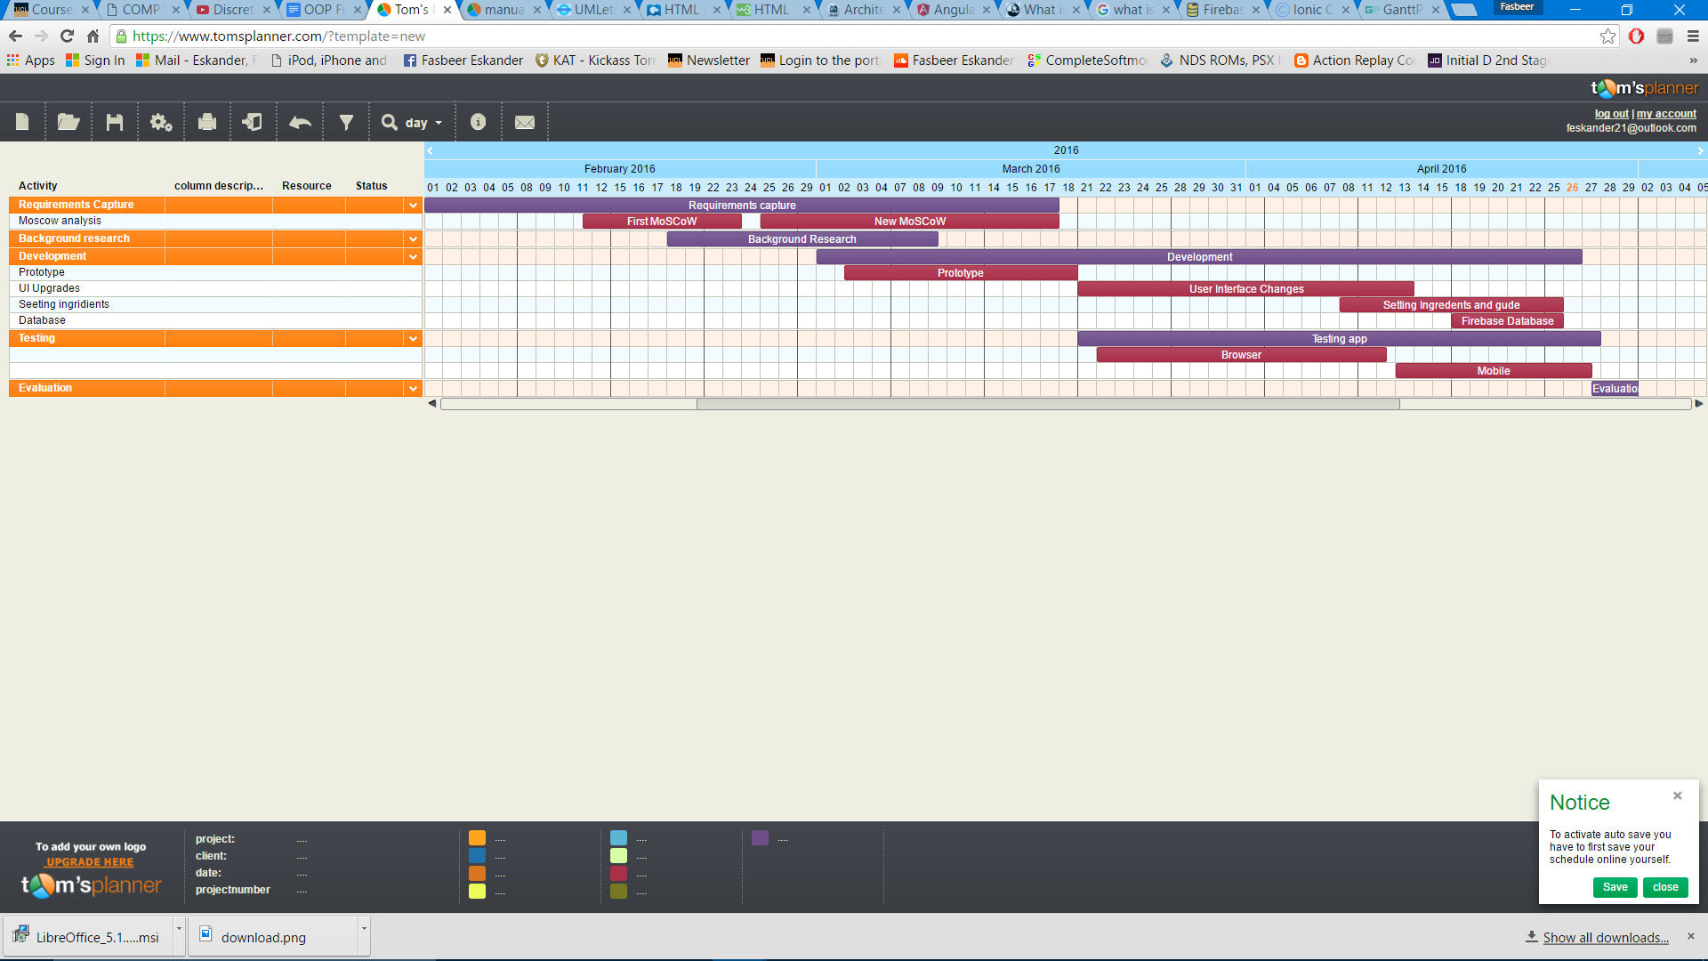

Figure 3: Gantt Chart.

## 5.2 Stages

As it can be seen on the Gantt Chart, we divided our project into the following stages:

* **Requirements Capture:** Listing the requirements obtained from discussions in the meeting and making the MoSCoW. However, because of the change in decision of the type of app the clients wanted, we had to do this twice, over a long period while researching and starting the development process.
  + MoSCoW: Prioritized the requirements according to the MoSCoW method.
* **Background Research:** We were both developing our first app. We had no prior knowledge in programming and hence needed to start learning everything from scratch. We learned mainly from [www.w3schools.com/](http://www.w3schools.com/) and also did research on using cordova to build the app, VMware to use Xcode and all the technologies listed in 3.1 This included
  + HTML5
  + CSS3
  + JavaScript
  + Apache Cordova
  + AngularJS
  + NetBeans
  + VMware
  + Xcode
  + Firebase
  + Ionic Creator
* **Development:** While doing our research, we started programming side by side as there was a loss of time during the decision change. The 4 main stages of developing the app were:
  + Prototype: using the paper prototypes and the MoSCoW requirements we first built a prototype on ionic creator and then deployed it to a phone
  + Use Interface: We changed the user interface here and there to make it look better and more user friendly.
  + Setting Ingredients and guides: We mailed the client for the list of ingredients and guides but could not receive all of them so included a default guide with all the ingredients available
  + Firebase Database: we made a database linking to our app using a firebase database.
* **Testing:** We carried out testing continuously during development to make sure the app was working and to correct anything when bugs appeared.
  + Testing on browser: With the code we had, we used google chrome to run the scripts we created to check if things were working as designed.
  + Testing on mobile devices: After a certain point we started testing the app on a mobile device to see how it looked and if it worked as required.
* **Evaluation:** Finally, we had to evaluate our progress by referring to the requirements and last but not least, the client feedback.

1. Evaluation, Conclusion and Future Works.

## 6.1 Evaluation.

We evaluated ourselves by rechecking the requirements and checking what we accomplished in the app.

**Must have**

Users are able to select from one to eight ingredients ✓

When “Start making tea” Button is clicked, music will be played until it countdowns to 0 ✓

(Recommended time for making tea varies)

Different ingredients or combinations corresponding to different music. 🗶

**Should have**

Categories 🗶

User are able to choose music that is downloaded from anywhere else to play. 🗶

While music is being played, some useful instructions are given on the screen. (e.g. add hot water now) 🗶

Users are able to request a password reset 🗶

User are able to set customized time for its tea. 🗶

Users are able to search by keyword 🗶

Users are able to submit feedback via the app. ✓

**Could have**

Users are able to share this app to any kinds of social media. 🗶

Users are able to login in with Facebook and Gmail ✓

Display recently teas made 🗶

Due to some difficulty and lack of information from the clients, we were unable to fulfill all of the requirements of the MoSCoW as seen by the ticks and cross given.

6.2 Conclusion

The app we designed were mainly UI based. Taking into consideration that we were completely new to programming, never built an app before or new the languages required also the requirements of the project, we believe the overall was fairly well. Despite not having met all the requirements we set on the MoSCoW, we managed to get the core requirements done and got the app to work despite the time limit we had. The miscommunication with the clients in the later dates and with them being a bit unresponsive caused a bit of problem for us. However, we still managed to finish the app and make a working solution with the resources that we had. Our exams in the end also caused a bit of problems with time management.  
  
  
6.3 Future Works

The application ChaTale would prove helpful to all the customers of the start-up who would ever like to blend their own tea. The developed app, while fulfilling the requirements, can still be improved a lot, to be more user friendly, a better guide, using machine learning to understand customer preferences and a better database can also be used for more information regarding different types of tea. For a company like ChaTale, following the requirements given in the first version of the MoSCoW, this app could app be made into the company’s own shopping app to order and get tea delivered to their homes and make it one all of their customers would love.

1. References

ChaTale - World's first Fine Tea Club . 2016. ChaTale - World's first Fine Tea Club . [ONLINE] Available at: http://www.chatale.co.uk/. [Accessed 27 April 2016].

UMLetino - Free Online UML Tool for Fast UML Diagrams. 2016. UMLetino - Free Online UML Tool for Fast UML Diagrams. [ONLINE] Available at: http://www.umlet.com/umletino/umletino.html. [Accessed 27 April 2016].

W3Schools Online Web Tutorials. 2016. W3Schools Online Web Tutorials. [ONLINE] Available at: http://www.w3schools.com/. [Accessed 27 April 2016].

HTML Tutorial. 2016. HTML Tutorial. [ONLINE] Available at: http://www.w3schools.com/html/default.asp. [Accessed 27 April 2016].

CSS Introduction. 2016. CSS Introduction. [ONLINE] Available at: http://www.w3schools.com/css/css_intro.asp. [Accessed 27 April 2016].

JavaScript Introduction. 2016. JavaScript Introduction. [ONLINE] Available at: http://www.w3schools.com/js/js_intro.asp. [Accessed 27 April 2016].

Architectural overview of Cordova platform - Apache Cordova . 2016. Architectural overview of Cordova platform - Apache Cordova . [ONLINE] Available at: https://cordova.apache.org/docs/en/latest/guide/overview/index.html. [Accessed 27 April 2016].

2016. . [ONLINE] Available at: https://docs.angularjs.org/guide/introduction. [Accessed 27 April 2016].

Welcome to NetBeans. 2016. Welcome to NetBeans. [ONLINE] Available at: https://netbeans.org/. [Accessed 27 April 2016].

Virtualization Technology & Virtual Machine Software | United States. 2016. Virtualization Technology & Virtual Machine Software | United States. [ONLINE] Available at: https://www.vmware.com/virtualization/overview. [Accessed 27 April 2016].

What is Xcode?. 2016. What is Xcode?. [ONLINE] Available at: https://www.lynda.com/Mobile-Apps-tutorials/What-Xcode/435788/451558-4.html. [Accessed 27 April 2016].

Firebase - Build Extraordinary Apps. 2016. Firebase - Build Extraordinary Apps. [ONLINE] Available at: https://www.firebase.com/. [Accessed 27 April 2016].

Ionic Creator. 2016. Ionic Creator. [ONLINE] Available at: http://ionic.io/products/creator. [Accessed 27 April 2016].

Tom's Planner: Online Gantt Chart - Project Planning software. 2016. Tom's Planner: Online Gantt Chart - Project Planning software. [ONLINE] Available at: https://www.tomsplanner.com/. [Accessed 27 April 2016].

# 8. Appendix

Old MoSCoW

Must have

* Users are able to register a new account and save personal information (e.g. address and phone number)
* Users are able to login in with registered username (preferably email address) and password
* Users are able to place an order and select from the list of ingredients (Min 1 Max 8 Total 100~)

Should have

* Categories
* Shopping basket
* Users are able to request a password reset
* Users are able to check the purchase history
* Users are able to search by keyword

Could have

* Users are able to leave customized message
* Users are able to login in with Facebook and Gmail
* Users are able to pay though the app via PayPal, debit or credit card
* Display recently viewed items

Won’t have

* Completed recommendation algorithm

Bi-weekly Reports:

Report 1:

We have met 7 times up to this point including the meeting with the Client. In the first two meetings, we got to know each other and each of our strengths and weaknesses while noting it down. During the Lab, we started getting to learn OOP in Java by doing the exercise sheets. In the meeting with the client we were introduced to the project she had in mind, and the overall requirements that she wanted the app to have. The app will be an online shopping app connected to the ChaTale company’s database to buy ingredients for tea online. There shall be a Login page to login using the user’s account or even sign in via Facebook. Following these and the other requirements given to us, we conducted more research on to the app’s topics and searched up its competitors. ChaTale appears to be one of its kind with no competitors as per our knowledge. After attending a 10 min meeting with Aisling, we understood the amount of the app requirements that our team could make and negotiated the terms of the fixed requirements with the client. The requirements were noted down in the MoSCoW format. A paper prototype was also made for the application in the form of sketches on how the app would look and a draft of the User Interface of the app itself. We managed to jot down the common variables, data types, and use cases to be used by the project to help us when we start developing the app. In the rest of the meetings, we learned more OOP at the labs and decided on how to design the app according to the requirements. Wentao (Team Leader) was in charge of taking the minutes in all the meetings we had.

During the next two weeks, we will begin the first stages of development of the app, using the knowledge that we’ve been learning from the UCL lecture, self-study and research conducted into the app’s topic and its requirements. We will meet with the client again to show our progress and discuss the paper prototypes further. We hope to get the information required from ChaTale about the different types of ingredients to start categorizing and setting up the lists.

Report 2:

During the past 2 weeks, we met up 5 times to plan out the development of the app and then started the development, meanwhile letting our client know about the difficulties we were facing and our progress. We showed the client the paper prototype we made for the app design according to the MoSCoW that was prepared. However, one of the requirements was that the app has to be for IOS, which we did not know how to program yet so we let them know that an IOS app would not be as good. Later a meeting with the client was set to negotiate the terms of the app again. The CEO of ChaTale along with its designer then decided to change their requirements and make a different app altogether. The new app would be an IOS app which plays music when the user is making tea, and stops to notify the user when the tea is ready. To make sure we meet their requirements we started learning the basics of xcode and swift to be able to develop an app for ios. After getting all the details and requirements, a new MoSCoW was made. Again we noted down the common variables, data types, and use cases to be used by the project to help us when we start developing the app. Wentao (Team Leader) was in charge of taking the minutes in all the meetings we had.

For the next two weeks, we wish to learn xcode and swift properly and continue the development of the app while showing our progress to the client. We will be holding another meeting to discuss the new paper prototypes for the new app design then start working on the User Interface. Information regarding the different types of tea and ingredients will also be collected from the client.

Report 3:

In the past two weeks, we started working on building a prototype for the app. Basically, the app we are going to develop is easier than the first model. And it is like a combination of a music player, a timer and a library, which is thought to be simple to build. We decided to use Cordova as our developing environment, where we should know how to write HTML, JS and CSS code. Before we actually build it, we amended our new MoSCoW method several times to meet the requirements deserved by our client. Fasbeer did the sketches using a great online tool, and it is also very powerful which enables us to get the source code of the sketches straight away. It saves us a lot of time, and we are still improving it. Wentao is in charge of amending the sketches for our IOS app, and meanwhile we are trying to build some basic functions on Cordova. Although we have no prior programming experience of any of those three language, it is found easy following the tutorials on w3school and Lynda.com. Also there are some libraries we can use directly.

Having looked into HTML for the first time, we learnt some fundamentals to build a simple user interface, and tried to change it by just editing the source until we found the ironic website is able to provide the source code for us.

It is difficult from the beginning for us, the laymen, who are new to JS and CSS to write code in either of them. On the contrary, we build on confidence progressively by trying several simple tasks out.

For next two weeks, we focus on JS and CSS, then test our prototype on a iPhone once we finish off the bits we are trying to do at the moment.

Report 4:

For the past two weeks, the two of us worked on learning the key components of cordova and developing apps for ios on a windows machine using JavaScript, HTML and CSS. Being beginners to both of these, we used w3schools.com for reference and help when we got stuck. We then decided that the work should be split up between the two of us and it was decided the Wentao would do the JS and CSS parts of the development and Fasbeer would focus on the HTML parts. Using the prototype from ioniccreater, we further developed the app with our knowledge and successfully managed to demo and simulate the app on an Iphone. As mentioned, Fasbeer worked on the HTML parts and Wentao worked on the JS and CSS parts and brought it all together for the complete demo. We have emailed the client about the demo and are currently waiting for their response on the subject. With their response, more data regarding the the ingredients, the time for making the different types of tea, and the rest of the requirements will be collected. We have met with Dr. Harry Strange in the past week to show our progress and describe where we currently stand with it. We split the marks between eachother Wentao-51, Fasbeer -49, according to the contribution throughout the weeks.

For the next weeks following the response from our clients with the relevant information, we will work on perfecting the interface of the app using the ingredients and time provide for each and demo the app to the clients once its done. We are also looking for a server that allow our users to register and login into the app.

First Bi-weekly report

**Summary of meetings**

**Meeting 1 (21/01/16):**

**Attendees:** Wentao and Fasbeer

* First team meeting to introduce ourselves.

**Meeting 2 (28/01/16):**

**Attendees:** Wentao and Fasbeer

* Checked background programming skills each team member has

**Meeting 3 (29/01/16):**

**Attendees:** Wentao, Fasbeer and Chantelle

* Met our client and discuss the requirements.

**Meeting 4 (06/02/2016):**

**Attendees:** Wentao and Fasbeer

* Discussed first-MoSCoW methods made.

**Meeting 5 (10/02/2016):**

**Attendees:** Wentao and Fasbeer

* Decided to use Cordova as we have no prior knowledge of swift

**Meeting 6 (11/02/2016):**

**Attendees:** Wentao and Fasbeer

* Discussed progress made
* Decided to learn HTML first

Second bi-weekly report

**Summary of meetings**

**Meeting 1 (17/02/16):**

**Attendees:** Wentao and Fasbeer

* Made a new MoSCoW

**Meeting 2 (18/02/16):**

**Attendees:** Wentao and Fasbeer

* Discussed Cordova and Ionic platforms, then decided to use ionic to create the framework of our app

**Meeting 3 (20/02/16):**

**Attendees:** Wentao and Fasbeer

* Finalised MoSCoW method

**Meeting 4 (22/02/2016):**

**Attendees:** Wentao and Fasbeer

* Built first Ionic app using Ionic Creator

**Meeting 5 (24/02/2016):**

**Attendees:** Wentao and Fasbeer

* Discussed progress of learning HTML

Third bi-weekly report

**Summary of meetings**

**Meeting 1 (02/03/16):**

**Attendees:** Wentao and Fasbeer

* Discussed how to test our app on windows

**Meeting 2 (05/03/16):**

**Attendees:** Wentao and Fasbeer

* Finalised the framework of our app using ionic creator

**Meeting 3 (08/02/16):**

**Attendees:** Wentao and Fasbeer

* Discussed the progress of learning AngularJS

**Meeting 4 (09/03/2016):**

**Attendees:** Yun Fu**,** Wentao and Fasbeer

* Milestone 2

Forth bi-weekly report

**Summary of meetings**

**Meeting 1 (14/03/16):**

**Attendees:** Wentao and Fasbeer

* Discussed several template apps

**Meeting 2 (16/03/16):**

**Attendees:** Wentao and Fasbeer

* Discussed which database we are going to use for login purpose

**Meeting 3 (18/02/16):**

**Attendees:** Wentao and Fasbeer

* Compared different databased, and decided to use firebase.

**Meeting 4 (20/02/2016):**

**Attendees:** Wentao and Fasbeer

* Ran our app on OS X installed on windows using VMware

**Meeting 5 (21/03/2016):**

**Attendees:** Wentao and Fasbeer

* Asked our client if our app was on the right path

**Meeting 6 (26/03/2016):**

**Attendees:** Dr Stange, Wentao and Fasbeer

* Discussed bi-weekly report
* Discussed progress so far

Meetings during the easter holiday

**Summary of meetings**

**Meeting 1 (28/03/16):**

**Attendees:** Wentao and Fasbeer

* Discussed plan for the easter holiday

**Meeting 2 (20/04/16):**

**Attendees:** Wentao and Fasbeer

* Discussed progress during the easter holiday

**Meeting 3 (25/04/16):**

**Attendees:** Wentao and Fasbeer

* Finalized our app

**Meeting 4 (26/04/2016):**

**Attendees:** Wentao and Fasbeer

* Made the video of our app

